Team 5 Project

One Player Ping-Pong game

Please provide a document describing your team project. Begin by including the information from your brainstorm. Then, define and specify the project that you created. Please try to review your designs and models in a systematic way, referencing the code you wrote (class designs) and the behavior of your program. After that, describe the differences between what was accomplished and what you intended to accomplish, recognizing the limits and constraints of the project as well as any knowledge gaps. Finally, please include some practical ideas about how future work could proceed.

**Introduction**

The player controls a racket by moving it horizontal across the left or right side of the screen. Player use the racket to hit a ball back and forth. Each time the ball hit racket; player receive one point. The goal is for player to get points as much as they could; game over when player’s racket misses catching ball.

There are 5 classes in Project. PingPong, PongPanel, BouncingBall, Player and Sprite.

**PingPong class:**

It is main frame which functions as base floor of the house. It has three methods.

static int[][] display(int[][] board) set up Team’s name board by using JFrame.

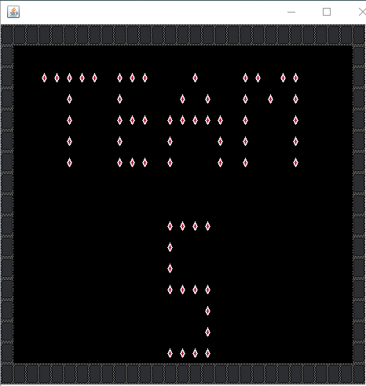

Team also uses BufferedImage and ImageIO.read to import image which is used to draw Team’s name.



*images.png*

PingPong() setup height and width of frame for PingPong game.

static void main(String[] args) will iterate codes of display(board) method and PingPong().

**PongPanel class:**

This GUI class is the house which contains other classes as rooms. It displays movements of racket and ball.

In this class, there are two checking method. One for ball when it hits left and right frame border and another method is when the ball hit the racket. Algorithm will calculate new coordination and repaint the ball to new locations.

If the ball hits bottom frame border, it is game over and a message will display player’s score.

Each time the ball hit racket; player receive one point. It will be added in player’s score which is displayed close to top border.

**BouncingBall class:**

This class creates size and color of the ball.

**Player class:**

This class creates size and color of the racket.

**Sprite class:**

*Not sure how to describe this class. I am not good in using words so if any one can take care of this, it would be great.*

**Analysis**

Accomplished:

Team succeeded in having ball bouncing when hit racket or both side frames with certain speed.

Score is calculated for each time ball hitting racket.

Intending to accomplish:

Speed of ball increasing when player’s score reaches over 10 points.

Ball will change color when it hits racket.